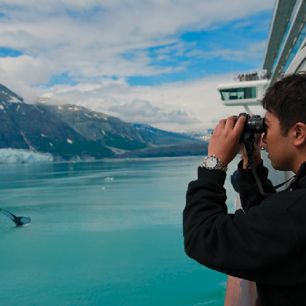
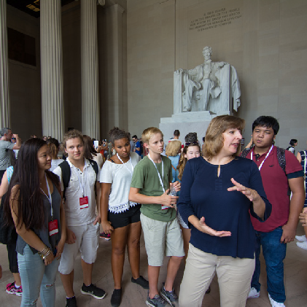
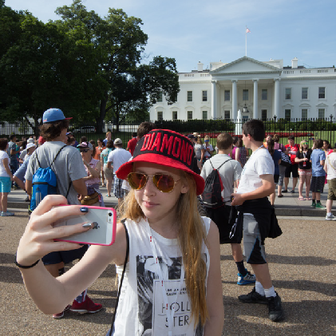
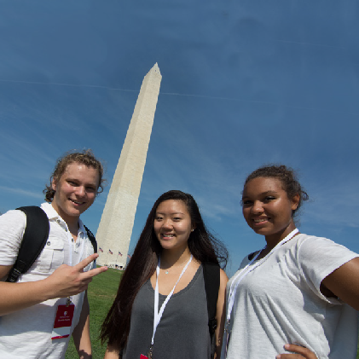

You’re Invited

to an important meeting about
Polson Middle School’s
Washington, D.C. Trip
Meeting Date and Time:
10/15/2020 at 6:00 PM
Meeting Location:
Via Google Meet: meet.google.com/yvp-hjed-awn

Come learn more about the trip and all that the students will see, do, and experience in Washington, D.C.!

Trip Dates: 4/6/2021 - 4/10/2021

Sign up at worldstrides.com/signup using Trip ID #: 183534

Questions? Contact: Mandy Ramesar at mramesar@polson.k12.mt.us

